1st April 2026
CHARGE HANDOVER

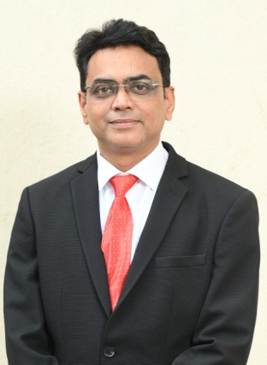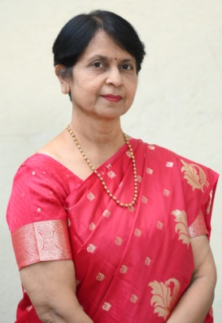
The Indian Medical Association (IMA), Nagpur Branch, has elected its new team of office bearers for the year 2026–27. Dr. Sachin Gathe, a renowned diabetologist in the city, has been appointed as the President.
The newly elected office bearers are as follows:
- Dr. Anjali Bhandarkar, eminent Gynaecologist – Hon. Secretary
- Dr. Aniruddha Deoke, MD (PSM), Epidemiologist – President Elect
- Dr. Manisha Rathi, senior Gynaecologist, and Dr. Prajakta Kaduskar, Consultant Adolescent Pediatrician – Vice Presidents
- Dr. Mukund Ganeriwal, well-known Consultant Physician – Hon. Treasurer
- Dr. Pallavi Alsi, Ophthalmologist, and Dr. Aditya Parihar, Pulmonologist – Hon. Joint Secretaries
- Dr. Shankar Khobragade – Hon. Asstt. Director, IMA CGP Nagpur Chapter
- Dr. Sanjay Jain – Hon. Asstt. Secretary, IMA CGP Nagpur Chapter
- Dr. Ajay Deshpande – Chairman, IMA AMS Nagpur Chapter
- Dr. Shubhangi Vairagade – Hon. Secretary, IMA AMS Nagpur Chapter
The newly elected team officially assumed charge on 1st April 2026.
The election process was conducted smoothly under the leadership of Dr. Krishna Parate, Chairman of the Election Commission, along with committee members Dr. Anand Kate and Dr. Pradeep Rajderkar. They extended their congratulations to the newly elected team.
The ceremony was graced by several esteemed members, including Dr. Rajesh Sawarbandhe, Immediate Past President, and Dr. Jitendra Sahu, Immediate Past Secretary, along with other office bearers of the 2025–26.
Prominent members present on the occasion included Dr. Ashok Adhao, Dr. Milind Naik, Dr. Y. S. Deshpande, Dr. Krishna Parate, Dr. Anand Kate, Dr. Prashant Nikhade, Dr. Anil Laddhad, Dr. Pradeep Rajderkar, Dr. Rajesh Ballal, Dr. B. K. Sharma, Dr. Warsha Dhawale, Dr. Sanjay Deshpande, Dr. Ajay Kate, Dr. Avinash Wase, Dr. Vaishali Khandait, Dr. Ashish Disawal, Dr. Kush Jhunjhunwala, Dr. Archana Kothari, Dr. Sanjay Deotale, Dr. Prakash Deo, Dr. Vandana Kate, and Dr. Manjusha Giri, who also conveyed their best wishes to the new team.
The IMA Nagpur Branch looks forward to working towards the betterment of the medical community and continuing its service to society under the leadership of this newly elected team.
3rd April 2026
‘Autism Anand Melawa’ Successfully Organized in IMA Nagpur
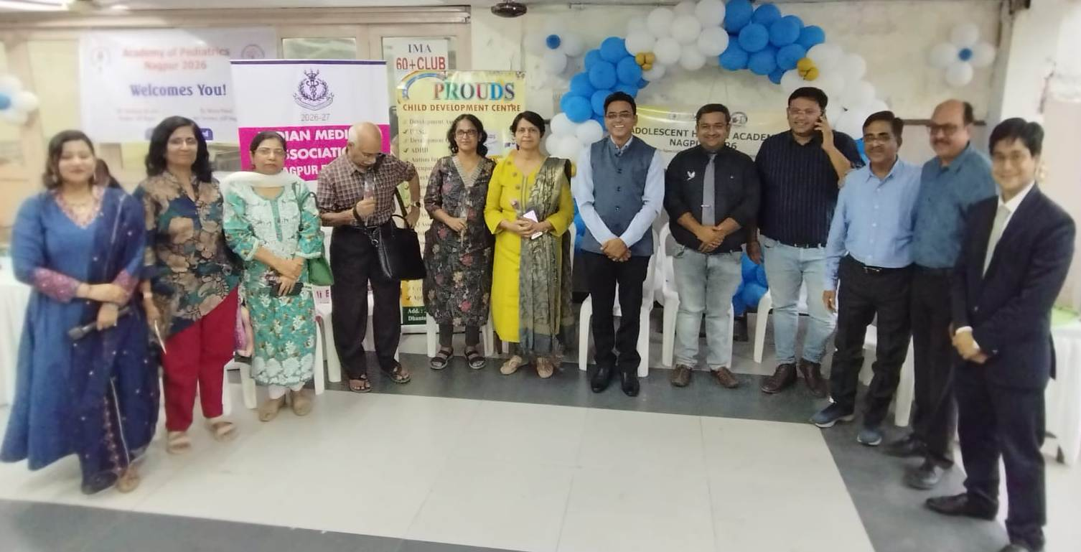
The Indian Medical Association (IMA), in collaboration with AHA and AOP, successfully organized ‘Autism Anand Melawa’ on 3rd April 2026 at IMA Hall, Nagpur.
The event witnessed an overwhelming response, with more than 400 parents of children with Autism attending and actively participating. The program was marked by enthusiastic involvement from children, their families, and dedicated support from PROUDS CDC therapists.
The Melawa featured a variety of engaging activities including fun games, creative stalls, and vocational awareness initiatives aimed at empowering children and their parents. A special highlight of the event was the positive affirmations session for parents, which inspired hope, resilience, and emotional strength.
The program was graced by eminent dignitaries including:
Dr. C. V. Chalapati Rao, Past Director NEERI, Nagpur
Dr. Sachin Gathe, President, IMA Nagpur;
Dr. Anjali Bhandarkar, Honorary Secretary, IMA Nagpur;
Dr. Prajakta Kaduskar, Vice President, IMA Nagpur;
Dr. Jitendra Sahu, Imm. Past Secretary, IMA Nagpur;
Dr. Mukund Ganeriwal, Treasurer, IMA Nagpur;
Dr. Kamlakar Deoghare;
Dr. Shubhada Khirwadkar;
Dr. Abhijit Bhardwaj (Past Chairpersons, AHA Nagpur);
Dr. Nirav Patel, Honorary Secretary, AOP Nagpur;
Dr. Dinesh Saroj, President, AHA, Nagpur
Dr. Yash Banait, Honorary Secretary, AHA Nagpur.
The event beautifully reflected the spirit of awareness, inclusion, and community support. The smiles, confidence, and joy seen on every face truly made the occasion meaningful and memorable.
The organizers reaffirmed their commitment to continue such initiatives to promote understanding, acceptance, and empowerment for children with Autism and their families.

5th April 2026
IMA, Nagpur & RCNI Organized Session on Income Tax Act 2025
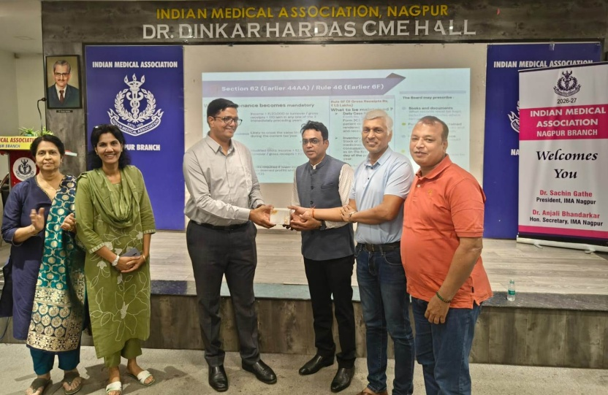

The Indian Medical Association (IMA), Nagpur Branch, in collaboration with Rotary Club of Nagpur Ishanya, organized an informative session on “Income Tax Act 2025: Insights, Readiness & Action Points” at Hardas Hall, IMA परिसर, South Ambazari Road, Nagpur.
The session witnessed participation from over 60 attendees, including doctors, businessmen, chartered accountants, and professionals from diverse fields, reflecting strong interest in understanding the evolving tax landscape.
Renowned tax expert CA Pavan Khabiya delivered an insightful address, highlighting key amendments in the Income Tax Act 2025, compliance preparedness, and practical strategies for effective tax planning.
The program was skillfully anchored by Rtn. Atul Bhaiya.
Dr. Sachin Gathe, President, IMA Nagpur Branch, addressed the gathering and emphasized the importance of financial awareness and preparedness among professionals.
On this occasion, Dr. Manisha Rathi, President, Rotary Club of Nagpur Ishanya, welcomed the IMA President with a sapling, while Rtn. Vinamra Khemuka felicitated Dr. Anjali Bhandarkar, Honorary Secretary, IMA Nagpur Branch, with a sapling as a mark of respect and appreciation.
The event was graced by the presence of senior Rotarians and past presidents including Dr. Vandana Kate, Dr Manisha Rathi Dr Pallavi Alsi, Dr. Mukund Ganeriwal , Dr Alok Umre and many Doctors, Rotarians and invitees
The session concluded with an engaging Q&A segment, followed by a vote of thanks proposed by Rtn. Vinamra Khemuka.
This initiative by IMA Nagpur Branch, in collaboration with Rotary Club of Nagpur Ishanya, marks a significant step towards enhancing awareness and readiness among professionals regarding the new tax framework.

7th April 2026
IMA & RST CANCER HOSPITAL OBSERVED WORLD HEALTH DAY
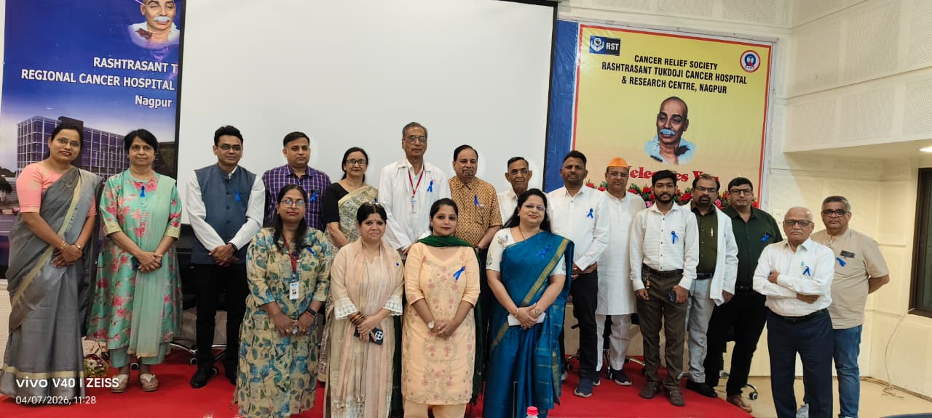
On the occasion of World Health Day, a special awareness programme was organized on 7th April 2026 at Rashtrasant Tukdoji Cancer Hospital & Research Centre, Nagpur.
The programme began with an introduction and garlanding of the portrait of Tukdoji Maharaj, paying tribute to his ideals of social service and community welfare.
During the programme, Mr. Shrirang Ganeshe, presented important data related to cancer and health awareness. This was followed by an informative presentation on “10 Rules to Suspect Cancer” by Dr. Prashant Somkuwar, who urged the attendees that if they observe any of these warning signs in themselves or among their relatives, should immediately report to Cancer Hospital for proper evaluation and guidance.

The event was attended by office bearers of Cancer Relief Society including Shri. Suresh Sharma, Vice President, Shri. Anil Malviya, Hon. Secretary, Shri. Suresh Kewalramani, Hon. Treasurer, and Shri. Dnyaneshwar Rakshak,
Member along with several doctors including Dr. Kartar Singh, Dr. Madhuri Gawande and Dr. Harish Kela and Dr. Rashmi Raut.
Several distinguished dignitaries addressed the audience during the programme, including Dr. Sachine Gathe, IMA President, Dr. Anjali Bhandarkar, Hon. Secretary, IMA Nagpur.
Secretary along with Dr. Uday Bodhankar, Dr. Madan Kapre and Shri. Sourabh Mohta, Director of True form Techno Pvt. Ltd., who shared their views on the importance of collective efforts in improving public health and strengthening cancer awareness in society.
Shri. Suresh Sharma spoke about preventing tobacco consumption among children. Dr. Sachin Gathe emphasized combined efforts for cancer awareness.
Shri. Dnyaneshwar Rakshak highlighted healthy eating. Dr. Uday Bodhankar spoke about HPV vaccination, while Shri. Sourabh Mohta, stressed spreading awareness in villages.
Various NGOs like Snehanchal, Hegdewar Blood Bank, Lions Club of Medicos, Shri. Gurudev Seva Mandal and many more attended the program.
The programme concluded with a vote of thanks by Dr. Prashant Somkuwar.
The event was successfully organized and conducted under the guidance of Dr. B. K. Sharma, Honorary Consultant, RST Cancer Hospital, Nagpur.

11th April 2026
WORLD AUTISM AWARENESS DAY 2026
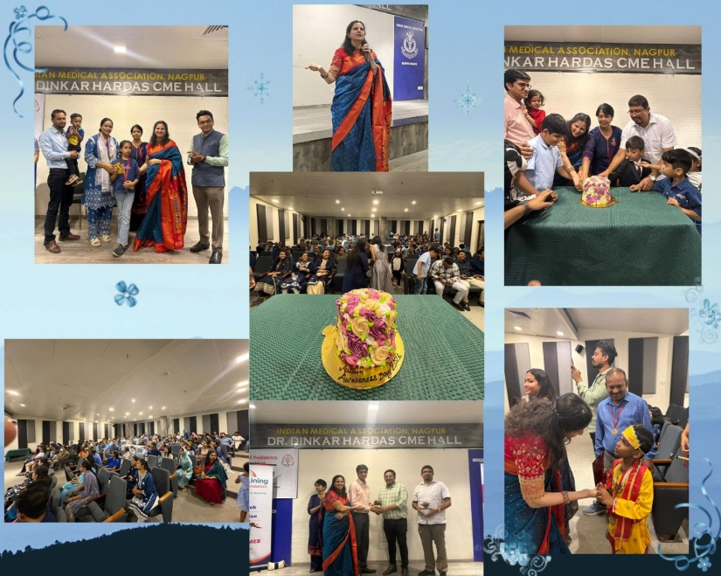
IMA Nagpur, Silver Lining Pediatric Super Speciality Center & Foundation, in association with AOP Nagpur and the Neurodevelopmental Pediatrics chapter, organized a vibrant cultural event yesterday (April 11, 2026) at IMA Annex Dr. Dinkar Hardas Hall in Nagpur for World Autism Awareness Day 2026. The event, themed "Nurturing Minds, Celebrating Differences – Autism and Humanity: Every Life Has Value," featured active participation from around 100 enthusiastic families.
Event Highlights
Children showcased their talents through various cultural performances, including an awareness drive by clinicians and parents, a fashion show by child duos, and a skit by therapists emphasizing parents' role as active leads in therapies while rejecting closed-door approaches. Fathers received special medals for their unwavering support during interventions. Chief guests from AOP and IMA felicitated the children and joined in cake cutting.
Key Message
Dr. Nirali Lohiya, developmental pediatrician and founder/director of Silver Lining Pediatric Super Speciality Center & Foundation, inspired parents to embrace children's unique strengths, shift focus from labels to functioning, and celebrate neurodiversity. The event ran from 3-5 PM with a blue dress code, followed by high-tea. Notable attendees included Dr. Sandeep Mogre (AOP President 2026), Dr. Sachin Gethe (IMA President 2026), Dr. Nikhil Lohiya, Dr. Nirav Patel (Secretary 2026), and Dr. Anjali Bhandarkar (IMA Secretary 2026).

19th April 2026
IMA Nagpur’s Appeal to Hon’ble Chief Minister to support Autonomy of MMC
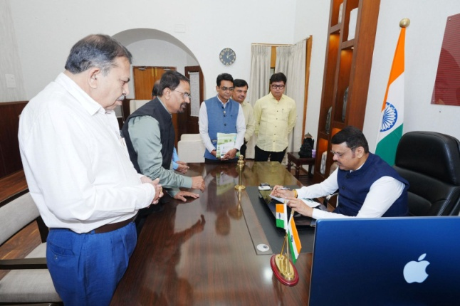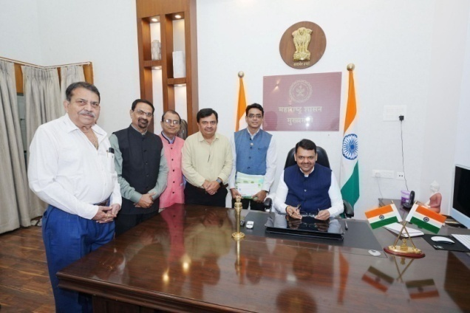
Under the leadership of Dr. Sachin Gathe, President, IMA Nagpur, Dr. Milind Naik, Dr. Y. S. Deshpande, Dr. Sanjay Deshpande, and Dr. Abhijeet Ambhaikar have submitted a representation to the Hon’ble Chief Minister of Maharashtra, Shri Devendra Fadnavis to request to extend support to retain the election system in the Maharashtra Medical Council and seeking his kind intervention to ensure that the autonomy of the Council is maintained.

26th April 2026
Blood Donation Camp Organized by IMA Nagpur and Sakhe Sobati Foundation
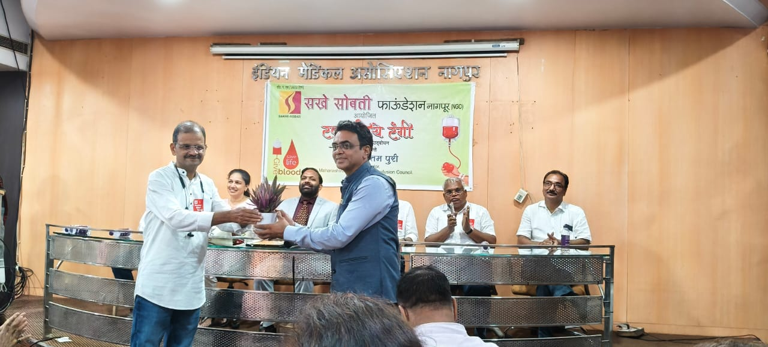
The Indian Medical Association (IMA), Nagpur, in collaboration with Sakhe Sobati Foundation, successfully organized a Blood Donation Camp on 26th April 2026 in memory of Late Dr. Shyam Chhadi, Radiologist from GMC Nagpur.
This noble initiative was conducted jointly with the 1986 Batch of GMC Nagpur, GMC Nagpur Blood Bank, VAPM, ASN, and CSI. The event was graced by Dr. Purushottam Puri, Assistant Director, State Blood Transfusion Council, Mumbai, Maharashtra, who attended as the Chief Guest.
The camp received an overwhelming and enthusiastic response from donors and volunteers alike, resulting in the collection of 232 units of blood, thereby making a significant contribution to the community’s healthcare needs.
The event was attended by several distinguished members, including:
- Dr. Sachin Gathe, President, IMA Nagpur
- Dr. Anjali Bhandarkar, Hon. Secretary, IMA Nagpur
- Dr. Sanjay Deotale
- Dr. Tulsi Chhadi
- Dr. Deepak Sane
- Dr. Sheetal Sane
- Dr. Pramod Gandhi
- Dr. Anupama Gupta
- Dr. Deepa Jahagirdar
Their gracious presence and active support greatly motivated the donors and volunteers, contributing to the grand success of the camp.

29th April 2026
*The Power of Silence*
International Noise Awareness Day
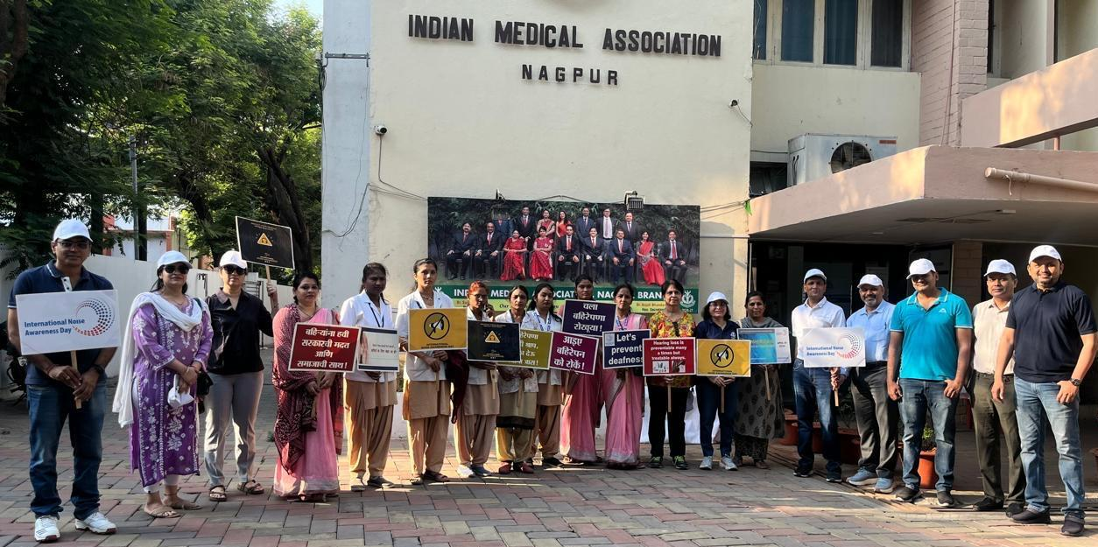

In a collective effort to combat the rising levels of urban noise pollution, *IMA Nagpur and AOI & HNS Vidarbha successfully organized a *public awareness rally* on the occasion of *International Noise Awareness Day* (29th April 2026). The event aimed to educate the public on the physiological and psychological impacts of excessive noise and to advocate for a quieter, healthier environment.

The rally commenced at 7:30 AM from the IMA Building. A significant number of senior consultants, ENT surgeons, and IMA office bearers marched alongside enthusiastic postgraduate students, carrying placards and banners highlighting the "ill effects of noise."

Following the march, a public address session was held where Dr Ashish Disawal, Senior ENT Surgeon and Chairman National Initiative for Safe Sound, IMA Maharashtra Chapter, Dr Ajay Deshpande, President AOI & HNS Vidarbha, Dr Sachin Gathe, President IMA and Dr Anjali Bhandarkar, Secretary IMA and briefed the gathering on how noise pollution contributes to hearing loss, hypertension, and sleep disorders.

Dr. Ajay Deshpande also stated that the purpose of the rally is to serve as a powerful reminder that silence is not just a luxury but a necessity for public health, and a means of driving the message of noise awareness to a wider audience.

The success of the event was made possible by the leadership of, IMA office bearers, Dr. Selokar (Chief NMC Health Officer) and Dr. Kadu (Nodal Officer), whose guidance and coordination were invaluable.

The presence of senior ENT surgeons—such as — such as *Dr. R. B. Deshmukh, Dr. Samir Thakare (National AOI Treasurer), Dr. Kanchan Tadke, Dr. Gauri Kapre Vaidya, Dr. Gaurav Agarwal, Dr. Pratik Parma, Dr. Vandana Mohta and Dr Kapil Gahukar* along with a high turnout of postgraduate students, added significant energy and momentum to the cause.

Additionally Dr. Naresh Agrawal* significantly boosted the campaign's reach with a viral YouTube video titled 'HORN NOT OKAY PLEASE.' Dr. Agrawal showcased his immense talent by writing the lyrics, providing the vocals, and delivering a fantastic performance that resonated widely online.

Furthermore, AOI HNS Vidarbha members Dr. Vishwas Dange from Pusad and Dr Siddheshwar Naringe from Brahmapuri also spearheaded noise awareness efforts in their respective regions.

The event received coverage from UCN News. The event was graciously sponsored by Soft Hear.

The march concluded back at IMA hall, where participants gathered for a post-event interaction over tea and snacks. Vote of thanks was given by Dr Disha Methwani, Secretary AOI & HNS Vidarbha.

AOI & HNS Vidarbha and IMA Nagpur extend their heartfelt gratitude to all members and students who participated in making this initiative a resounding success.

29th April 2026
Dr. Sachin Gathe President IMA felicitated Dr.Sanjay Deshpande &
Dr. Mangesh Gulwade
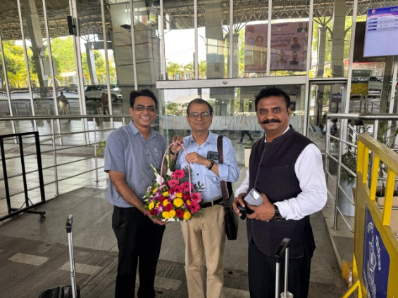
Dr. Sachin Gathe, President of IMA Nagpur, felicitated Dr. Sanjay Deshpande and Dr. Mangesh Gulwade on being elected to the MMC Panel.

